"Okay, let me begin with a touch of sass."

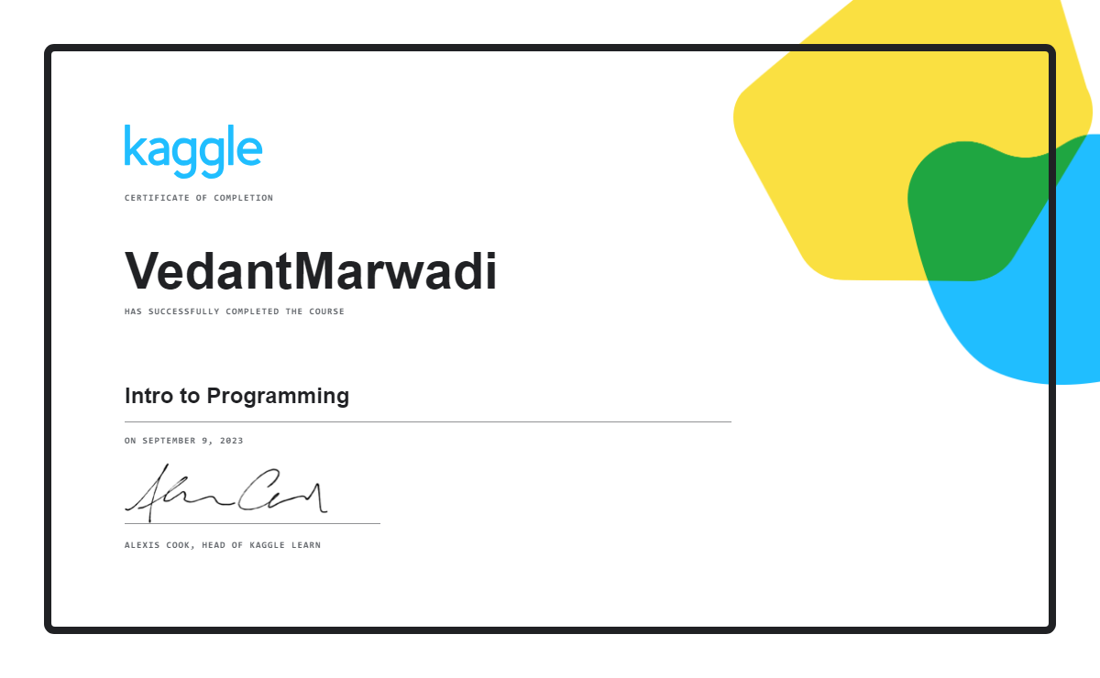

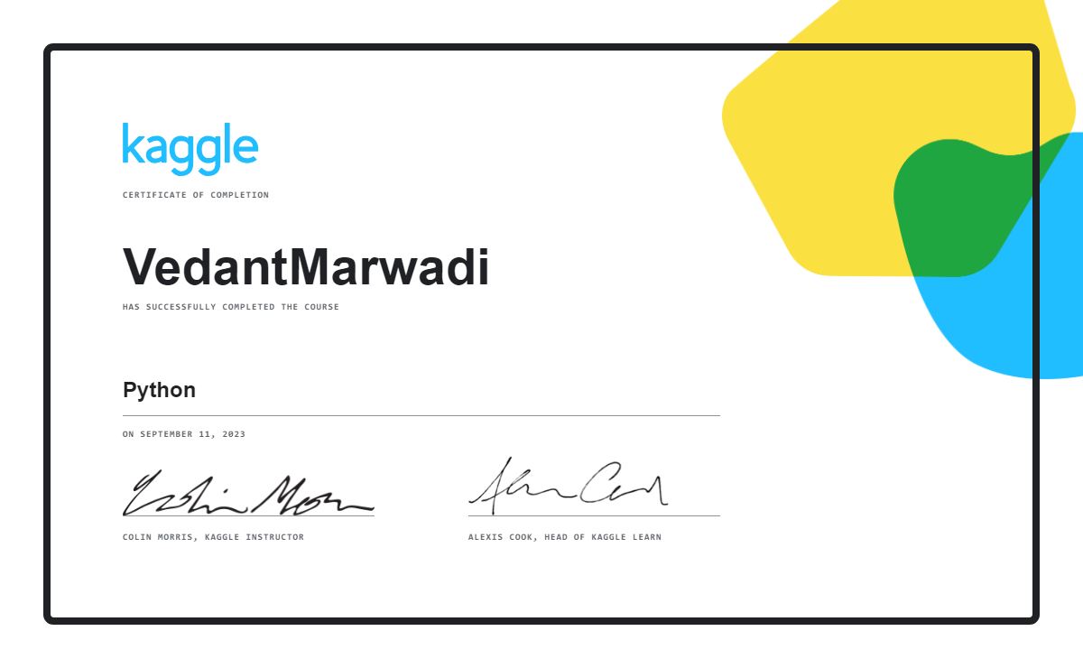

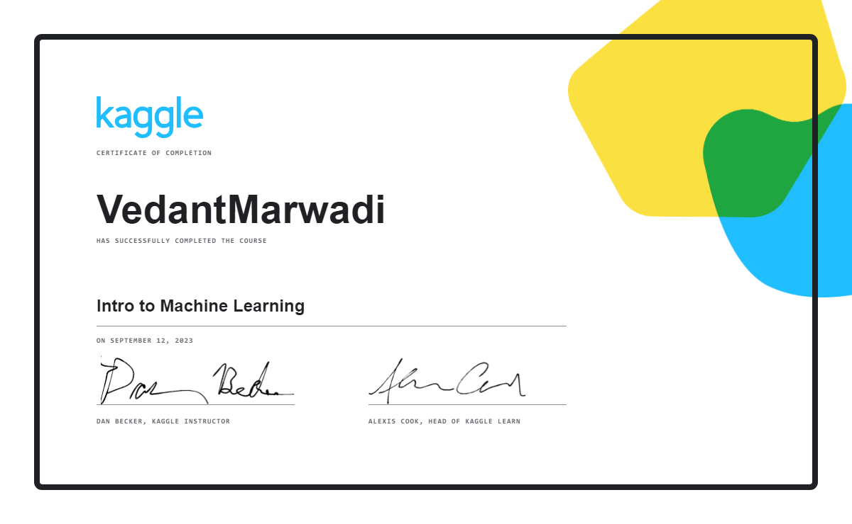

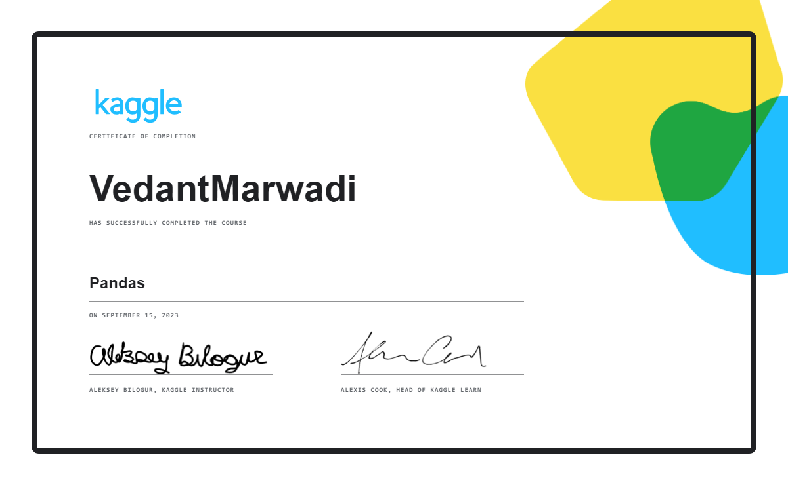

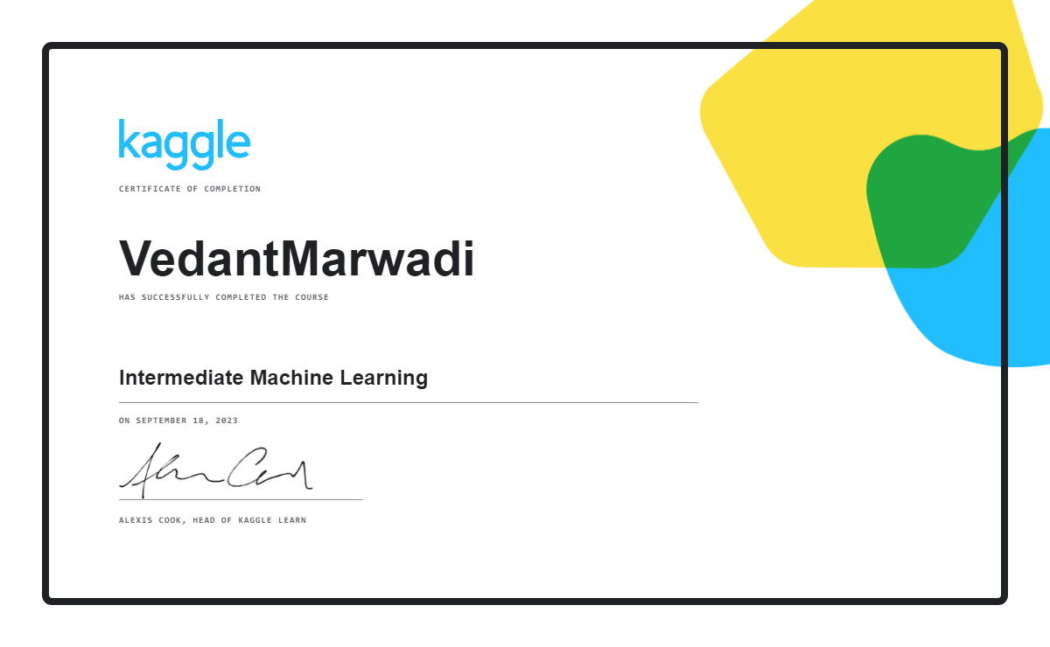

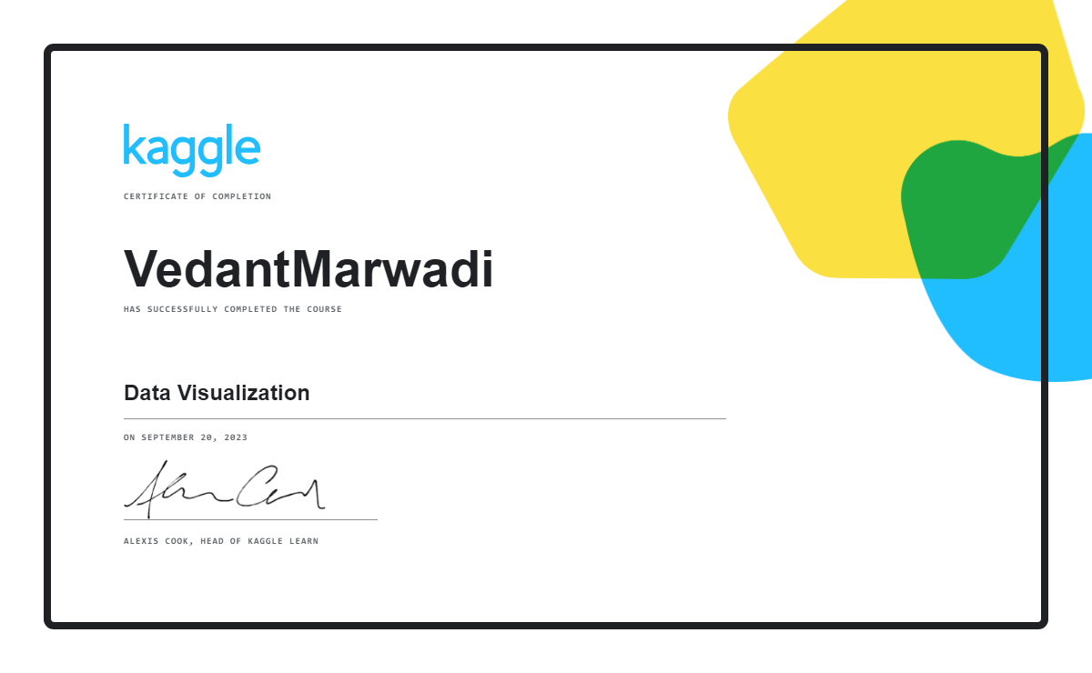

AI & ML & DL

artificial intelligence tutorial for beginners | edureka! - [https://youtu.be/jmuxmlyrhsk?si=drymzjj2gmdbpzih](https://youtu.be/JMUxmLyrhSk?si=dryMZjj2GmdBpZih)

🔮 if i had to do this course again, i'd give myself a leisurely five days to wrap it up, with just an hour of learning each day. whenever i stumble upon tricky stuff in the videos, i won't sweat it. i'll simply hop on google, watch a bunch of youtube clips, scour the web, and maybe even have a chat with chat gpt to really get a grip on those tricky bits. once i've got a handle on things, i'll keep moving forward. no worries, five days should be plenty with this laid-back approach. oh, and i'd probably just skim through the last few bits of the course, like deep learning and llm, since i've got separate courses lined up for those down the road.

＞﹏＜ topics that i covered from this video ＞﹏＜

history of ai

demand for ai

what is artificial intelligence?

ai applications

types of ai

programming languages for ai

introduction to machine learning

need for machine learning

what is machine learning?

machine learning definitions

machine learning process

types of machine learning

💥 supervised learning

💥 unsupervised learning

💥 reinforcement learning

supervised vs unsupervised vs reinforcement learning

types of problems solved using machine learning

supervised learning algorithms: -

💥 linear regression

💥 logistic regression

💥 decision tree

💥 random forest

💥 naive bayes

💥 k nearest neighbour (knn)

💥 support vector machine (svm)

unsupervised learning algorithms: -

💥 k-means clustering

reinforcement learning:-

💥reinforcement learning example

💥terminologies in reinforcement learning

💥reward maximization

💥exploration and exploitation

💥marko’v decision process

💥q learning algorithm

💥demo (reinforcement learning)

ai vs machine learning vs deep learning

limitations of machine learning

how deep learning works?

what is deep learning?

deep learning use case

single layer perceptron

multi layer perceptron (ann)

backpropagation

training a neural network

limitations of feed forward network

recurrent neural networks

convolutional neural networks

natural language processing

what is text mining?

what is nlp?

applications of nlp

terminologies in nlp

💥 tokenization

💥 stemming

💥 lemmatization

💥 stop words

💥 document term matrix

machine learning tutorial python | machine learning for beginners | codebasics - [https://youtube.com/playlist?list=pleo1k3hjs3uvcetyteyfe0-rn5r8zn9rw&si=anrn-qz3vj97riqj](https://youtube.com/playlist?list=PLeo1K3hjS3uvCeTYTeyfe0-rN5r8zn9rw&si=anRN-Qz3vJ97RIQj)

🔮 if i had to do this course over, i'd watch four videos each day and make sure i tackle both the tutor's tasks and the exercises they assign. i'd keep things organized by creating a folder for all the python files. the course is actually pretty straightforward. oh, and i wouldn't bother with those two projects in the course since we're planning to do a bunch of separate machine learning projects. this way, i reckon i'd wrap up the course in just six days, no more.

＞﹏＜ topics that i covered from this video ＞﹏＜

what is machine learning?

linear regression single variable

linear regression multiple variables

gradient descent and cost function

save model using joblib and pickle

dummy variables & one hot encoding

training and testing data

logistic regression (binary classification)

logistic regression (multiclass classification)

decision tree

support vector machine (svm)

random forest

k fold cross validation

k means clustering algorithm

naive bayes classifier algorithm

hyper parameter tuning (gridsearchcv)

l1 and l2 regularization | lasso, ridge regression

k nearest neighbors classification with python code

principal component analysis (pca) with python code

bias vs variance in machine learning

ensemble learning – bagging

feature engineering

complete machine learning course in 60 hours | siddhardhan – [https://www.youtube.com/watch?v=lcwfedjar4q&list=plffghezkvmjvii5zcbnfwqoujtuvddnmo&index=2](https://www.youtube.com/watch?v=LcWFedjaR4Q&list=PLfFghEzKVmjvII5ZcBnFWQOUjtUVdDnmo&index=2)

＞﹏＜ topics that i covered from this video ＞﹏＜

ai vs ml vs dl

types of machine learning

supervised learning & its types

unsupervised learning & its types

deep learning

google colaboratory - basics

python basics

basic data types in python

list, tuple, set, dictionary

operators in python

if else statement in python

loops in python

functions in python

numpy tutorial

pandas tutorial

matplotlib tutorial

seaborn tutorial

data collection for ml

importing datasets through kaggle api

handling missing values

data standardization

label encoding

train test split

handling imbalanced dataset

feature extraction of text data

numerical dataset processing

textual data processing

ml use case 1: rock vs mine prediction

ml use case 2: diabetes prediction

ml use case 3: spam mail prediction

CLOUD COMPUTING & AWS

🔮 If I had to do it all over again, I'd start by getting the hang of networking stuff first.

Computer Networks | Neso Academy - [https://youtube.com/playlist?List=plblnk6feyqrgmcuag0xrw78ua8qnv6jex&si=8ba93waziljcdvno](https://youtube.com/playlist?list=PLBlnK6fEyqRgMCUAG0XRw78UA8qnv6jEx&si=8ba93WaziLJcdVnO)

＞﹏＜ topics that I covered from this video ＞﹏＜

🔮 After that, I'd dive into learning Linux.

Wscube Tech - [https://youtu.be/hqr3qt0xjxw?Si=vh0psmfrmylv9kel](https://youtu.be/hqR3qt0XjXw?si=vh0PsMFrmYlv9kEL)

＞﹏＜ topics that I covered from this video ＞﹏＜

what is linux?

how to install linux?

linux file system

linux commands

how to change linux host and hostname

how to install third-party software in ubuntu/linux

error resolving apt

how to run two or more terminal commands at once in linux

terminal shortcuts

freecodecamp.org - [https://youtu.be/swbudq4s6y8?si=xuqkiw95hleju0xm](https://youtu.be/sWbUDq4S6Y8?si=xUqKIw95HLeJu0xM)

＞﹏＜ topics that i covered from this video ＞﹏＜

🔮 afterward, i'd take a quick look at what the whole deal with cloud, cloud computing, and aws is all about.

cloud computing full course | edureka! -[https://youtu.be/2laajq1lb1q?si=mjf1bvraiq_zkzqs](https://youtu.be/2LaAJq1lB1Q?si=MjF1BvRAIQ_ZkZqs)

＞﹏＜ topics that i covered from this video ＞﹏＜

introduction to cloud

* before cloud computing
* why cloud?
* [https://youtu.be/jue9gkns5sa?si=6sb_shhrg79gfpck](https://youtu.be/JuE9gKNs5sA?si=6SB_sHHrg79GfPCk)
* what is cloud?
* what is cloud computing?

service models

* [https://youtu.be/zr48j9xhaw4?si=tkwd4dipw-b6mnqf](https://youtu.be/zr48J9Xhaw4?si=TKWD4diPW-b6MNQF)
* iaas
* paas
* saas

deployment models

* [https://youtu.be/omfunoykxig?si=til9vkakjhoqqrmw](https://youtu.be/OmfUnOYKxIg?si=Til9vkAkJhoqqrMw)
* public cloud
* private cloud
* hybrid cloud

cloud service providers

on premise vs cloud computing

cloud computing myths

different cloud engineer roles

* cloud architect
* cloud developer
* sysops administrator
* 

what is aws?

* why aws?
* who is using aws?
* benefits of aws

aws global infrastructure

* regions
* [https://youtu.be/jrgw4uinhke?si=caqu2jtlgawk2x_u](https://youtu.be/jRGW4uInhkE?si=caqU2JtlgaWK2X_U)
* availability zones (az)
* [https://youtu.be/fh5828qh4_k?si=nsxbaqv_ibdneytj](https://youtu.be/fH5828qH4_k?si=NSxBAQV_IBdnEyTJ)
* edge locations
* local zones
* [https://youtu.be/wf5xs6jouz0?si=raagnj4c_bbk5zee](https://youtu.be/WF5XS6jOUZ0?si=RAagnJ4c_bBK5zEE)

aws free tier sign up

* [https://youtu.be/qdymcz5xyow?si=0qhg8fnqfskd-s-n](https://youtu.be/QDymcZ5xYow?si=0qHg8FNqfskD-s-n)

aws service domains / services

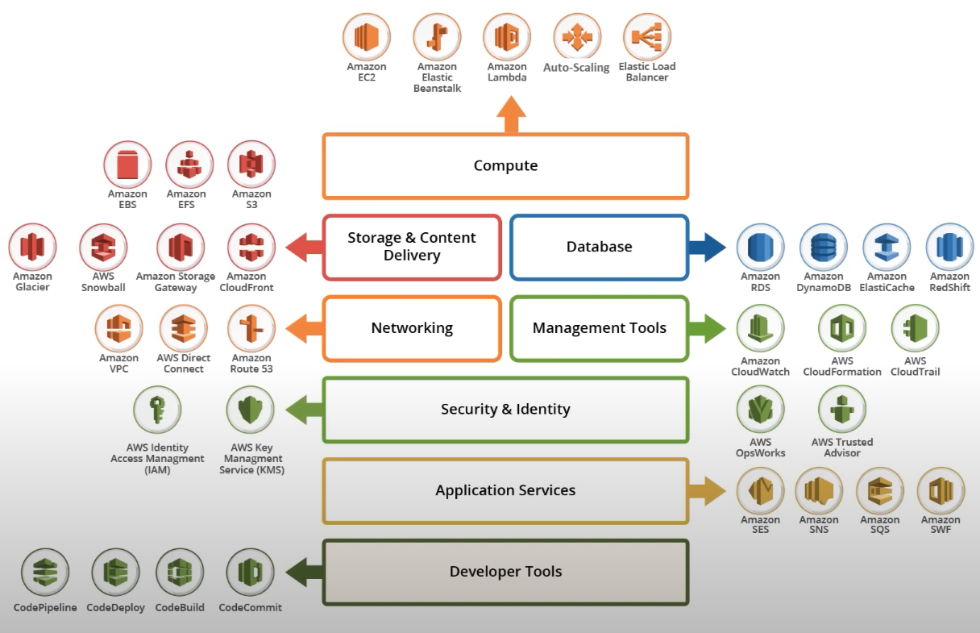

ways to access aws resources / services

* aws cli
* sdks
* management console

🔮 Finally, I'd just jump right into learning AWS.

Gaurav Sharma <https://youtube.com/playlist?list=PL6XT0grm_TfgtwtwUit305qS-HhDvb4du&si=m1Ywb0S32Ra8v73q>

＞﹏＜ topics that I covered from this video ＞﹏＜

AWS Certified Cloud Practitioner Certification Course | freeCodeCamp.org -<https://youtu.be/SOTamWNgDKc?si=epDeLeY_IO6uFRLw>

or <https://youtube.com/playlist?list=PLBfufR7vyJJ4du5ANexy0SuQ0J7KhRcjI&si=2ei9srPScyUihTzZ>

or

<https://www.exampro.co/clf-c01>

＞﹏＜ topics that I covered from this video ＞﹏＜

# Introdution

Is CCP right for me?

Exam Guide Walkthrough

Practice Exam Sample

# Cloud Concepts

☑ What is Cloud Computing?

Evolution of Cloud Hosting

What is Amazon?

What is AWS?

What is a Cloud Service Provider?

Landscape of CSPs

Gartner Magic Quadrant for Cloud

AWS Services Preview

Evolution of Computing

Types of Cloud Computing

Cloud Computing Deployment Models

# Getting Started

Create an AWS Account

Create IAM User

AWS Region Selector

Overbilling Story

AWS Budgets

AWS Free Tier

Billing Alarm

Turning on MFA

# Digital Transformation

Innovation Waves

Burning Platform

Digital Transformation Checklist

Evolution of Computing Power

Amazon Braket

# The Benefits Of Cloud

The Benefits of Cloud

The Six Advantages of Cloud

The Six Advantages of Cloud Doc Reference

The Seven Advantages of Cloud

# Aws Global Infrastructure

AWS Global Infrastructure Overview

Regions

Regions vs Global Services

Availability Zones (AZs)

Regions vs AZ Visualized

Fault Tolerance

AWS Global Network

Points of Presence (PoP)

Tier 1

AWS Services using PoPs

AWS Direct Connect

Direct Connect Location

AWS Local Zones

Wavelength Zones

Data Residency

AWS for Government

GovCloud

AWS in China

2:07:30 Sustainability

2:10:35 AWS Ground Station

2:11:54 AWS Outposts

# Cloud Architecture

Cloud Architecture Terminologies

High Availability

High Scalability

High Elasticity

Fault Tolerance

High Durability

Business Continuity Plan

Disaster Recovery Options

RTO Visualized

RPO Visualized

Architectural diagram examples

# Management And Development Tools

AWS API

AWS Management Console

Service Console

AWS Account ID

AWS Tools for PowerShell

Amazon Resource Names

AWS CLI

AWS SDK

AWS CloudShell

Infrastructure as Code (But says AWS CLI, maybe wrong)

CloudFormation

CDK

AWS Toolkit for VSCode

Access Keys

AWS Documentation

# Shared Responsibility Model

Introduction to Shared Responsibility Model

AWS Shared Responsibility Model

Types of Cloud Responsibilities

Shared Responsibility for Compute

Shared Responsibility Model Alternate

Shared Responsibility Model Architecture

# Compute

EC2 Overview

VMs, Containers and Serverless

High Performance Computing (HPC)

Edge and Hybrid

Cost & Capacity Management

# Storage

Types of Storage Services

Introduction to S3

S3 Storage Classes

AWS Snow Family

Storage Services

S3

EBS

EFS

Snow Family

# Databases

What is a Database

What is a data warehouse?

What is a key value store?

What is a document database?

NoSQL Database Services

Relational Database Services

Other Database Services

# Networking

Cloud-Native Networking Services

Enterprise/Hybrid Networking Services

Virtual Private Cloud (VPC) & Subnets

Security Groups vs NACLs

AWS CloudFront (FA)

# Ec2

Introduction to EC2

EC2 Instance Families

EC2 Instance Types

Dedicated Host vs Dedicated Instances

EC2 Tenancy

Launch an EC2, SSH and Sessions Manager

Elastic IP

AMI and Launch Template

Launch an ASG

Launch an ALB

# Ec2 Pricing Models

EC2 Pricing Models

On Demand

Reserved

RI Attributes

Regional and Zonal RI

RI Limits

Capacity Reservations

Standard vs Convertible RI

RI Marketplace

Spot

Dedicated

Savings Plan

# Identity

Zero-Trust Model

Zero-Trust on AWS

Zero-Trust on AWS with Third-Parties

Directory Service

Active Directory

Identity Providers

Single-Sign-On

LDAP

Multi-Factor-Authentication

Security Keys

AWS IAM

Anatomy of an IAM Policy

Principle-of-Least-Privilege

AWS Account Root User

AWS SSO

# Application Integration

Introduction to Application Integration

Queueing and SQS

Streaming and Kinesis

Pub-Sub and SNS

API Gateway and Amazon API Gateway

State Machines and AWS Step Functions

Event Bus and Amazon Event Bridge

Application Integration Services

# Containers

VMs vs Containers

What are Microservices?

Kuberenetes

Docker

Podman

Container Services

# Governance

Organizations and Accounts

AWS Control Tower

AWS Config

AWS Quick Starts

Tagging

Resource Groups

Business Centric Services

# Provisioning

Provisioning Services

AWS Elastic Beanstalk

# Serverless Services

What is Serverless?

Serverless Services

# Windows on AWS

Windows on AWS

AWS License Manager

# Logging

Logging Service

AWS Cloud Trail

CloudWatch Alarm

Anatomy of an Alarm

Log Events

Log Insights

CloudWatch Metrics

# ML, AI and Big Data

Introduction to ML and AI

AI and ML Services

BigData and Analytics Services

Amazon QuickSight

# AWS Well-Architected Framework

AWS Well-Architected Framework

General Defintions

On Architecture

Amazon Leadership Principles

General Design Principles

Anatomy of a Pillar

Operational Excellence

Security

Reliability

Performance Efficiency

Cost Optimization

AWS Well-Architected-Tool

AWS Architecture Center

# TCO and Migration

TCO and Migration

Total Cost of Ownership (TCO)

CAPEX vs OPEX

Shifting-IT Personnel

AWS Pricing Calculator

Migration Evaluator

VM Import Export

Database Migration Service

Cloud Adoption Framework

# Billing, Pricing and Support

AWS Free Services

AWS Support Plans

Technical Account Manager

AWS Marketplace

Consolidated Billing

Consolidated Billing Volume Discounts

AWS Trusted Advisor

SLAs

AWS SLA Examples

Service Health Dashboard

AWS Personal Health Dashboard

AWS Abuse

AWS Free Tier

AWS Credits

AWS Partner Network

AWS Budgets

AWS Budget Reports

AWS Cost and Usage Reports

Cost Allocation Tags

Billing Alarms

AWS Cost Explorer

Programmatic Pricing APIs

# Security

Defense-In-Depth

CIA Triad

Vulnerabilities

Encryption

Cyphers

Cryptographic Keys

Hashing and Salting

Digital Signatures and Signing

In-Transit vs At-Rest Encryption

Compliance Programs

Pen Testing

AWS Artifact

AWS Inspector

DDoS

AWS Shield

AWS Guard Duty

AWS Guard Duty Follow Along

Amazon Macie

AWS VPN

AWS WAF

Hardware Security Module

AWS KMS

CloudHSM

# Variation Study

Know Your Initialisms

AWS Config AWS AppConfig

SNS vs SQS

SNS vs SES vs PinPoint vs Workmail

Amazon Inspector vs AWS Trusted Advisor

Connect Named Services

Elastic Transcoder vs MediaConvert

AWS Artifact vs Amazon Inspector

ELB Variants

GIT & GITHUB

Codewithharry -https://youtube.com/playlist?list=plu0w_9lii9agwhy658zpa0mtstkujtwpi&si=bgr9rotligcjw9tg

＞﹏＜ topics that I covered from this video ＞﹏＜

what is git/github & why do we need it?

installing git + initial setup

git: three stage architecture

tracking first git project

cloning a remote git repository from github

git: file status lifecycle

gitignore: ignoring files in git

git diff: showing changes between commits/staging area & working directory

git: skipping the staging area

moving and renaming files in git

git log: viewing & changing commits in git

unstaging & unmodifying files in git

github: working with remote

setting alias in git

git: creating & switching branches in git

branching & merging a production grade

resolving merge conflicts

git branching workflow in production

pushing git branches to remote repositories

freeCodeCamp.org -https://youtu.be/RGOj5yH7evk?si=0PZ0rtAqwKTddNUJ

＞﹏＜ topics that I covered from this video ＞﹏＜

- [00:00](https://www.youtube.com/watch?v=sWbUDq4S6Y8&t=0s) 🐧 This course is an introduction to Linux designed for beginners, covering various tools, system configurations, command line operations, and common Linux applications.

- [02:56](https://www.youtube.com/watch?v=sWbUDq4S6Y8&t=176s) 📦 Linux has three major distribution families: Red Hat, SUSE, and Debian, each with its own set of distributions.

- [07:35](https://www.youtube.com/watch?v=sWbUDq4S6Y8&t=455s) 🤓 It's important to understand key Linux terms like kernel, distribution, bootloader, service, file system, X Windows system, desktop environment, and command line.

- [17:18](https://www.youtube.com/watch?v=sWbUDq4S6Y8&t=1038s) 🖥️ The Linux boot process involves BIOS initialization, bootloader, kernel loading, initramfs, user login, and the initiation of system processes.

- [26:15](https://www.youtube.com/watch?v=sWbUDq4S6Y8&t=1575s) 💽 Linux uses partitions and file systems to organize data, and it follows the File System Hierarchy Standard (FHS) to maintain a standard layout.

28:52 📁 Linux distributions have different directories, such as core utilities and other programs, placed under specific directories like /usr and /etc.

29:45 🖥️ When exploring the file system hierarchy in Ubuntu's graphical interface, you can navigate by opening the file manager, clicking "Computer," and exploring directories like /etc.

31:15 🤔 Choosing a Linux distribution should consider factors like its main function, required packages, available hardware, update frequency, and support cycle.

32:27 💽 Partition layout during installation should be planned carefully, considering the system's needs and the distribution's default layout options.

35:24 🌐 The Linux installation process typically involves booting from installation media, answering configuration questions, and optionally installing updates, with variations across distributions and methods.

57:42 🖥️ Linux allows for customization during installation, including partition schemes and desktop preferences.

59:44 🌐 Linux offers choices for language, time zone, and desktop environment during installation.

01:05:14 🛡️ Linux is a multi-user operating system, allowing multiple users to have individualized settings and home directories.

01:16:04 🔄 Linux distributions have similar procedures for booting, logging in, and shutting down, regardless of the specific distribution.

01:19:00 🔒 You can easily lock and unlock your screen in Linux to prevent unauthorized access while keeping your sessions active.

01:25:08 📦 Linux distributions come with default applications, but you can install more apps like web browsers (e.g., Firefox, Chrome) from software repositories.

01:25:49 🖥️ You can easily set default applications on Linux by accessing the settings menu, choosing "Default Applications," and selecting your preferred apps.

01:27:09 📂 The Nautilus file manager is used to navigate the file system in Linux. It displays commonly used directories like Desktop, Documents, and Downloads.

01:29:14 🔍 You can customize the file manager's view, arrange files, and show hidden files (configuration files starting with a dot) in Linux.

01:30:41 🗑️ Deleting files in Nautilus moves them to the trash folder under the user's home directory. You can permanently delete files from the trash or bypass it.

01:52:58 📦 Linux uses different package management systems, such as APT for Debian-based systems and RPM for Red Hat-based systems.

01:55:13 💻 Linux administrators often perform package management from the command line but can also use graphical package managers like GNOME Software and Synaptic.

02:11:41 🌐 Linux offers a variety of internet applications, including web browsers, email clients, online media players, and office suites.

02:14:06 🖥️ Command line interfaces in Linux provide advantages like automation, remote access, and the ability to execute tasks efficiently.

02:19:10 🔑 Setting up sudo allows users to run commands with administrative privileges, enhancing security and control on Linux systems.

02:22:05 🔌 Virtual terminals (VTs) in Linux are like separate text-based interfaces. You can switch between them using Ctrl+Alt+Function keys, useful for troubleshooting graphical issues.

02:23:32 🖥️ Linux distributions have different methods to start and stop the graphical desktop environment, like using display managers or systemctl commands.

02:24:11 📂 You can perform basic file operations in Linux, including logging in, accessing directories, and navigating the file system.

02:25:39 ⚠️ Properly shut down or reboot Linux systems using the "shutdown" command to prevent data loss and system damage.

02:32:45 ↔️ Linux supports hard links (multiple names for the same file) and soft links (symbolic links pointing to other files). Understand their differences and usage.

02:49:35 🧭 You can search for files in Linux using tools like locate and find, and use the grep command to filter results.

02:51:12 🕵️‍♂️ To update the database used by the locate command, run updatedb as the root user.

02:54:02 🃏 You can use wildcards like * and ? to search for files with specific characters or patterns in their names.

02:58:06 🗂️ The find command is a powerful tool for searching and performing actions on files based on various criteria.

03:07:12 📦 Package management in Linux involves low-level tools (e.g., dpkg or RPM) and high-level tools (e.g., apt-get, dnf, yum, zipper) for installing, removing, and managing software packages.

03:37:24 🔄 A process in Linux is an instance of one or more related tasks or threads, responsible for executing programs and utilizing system resources.

03:38:40 ⏳ Processes can be of different types, including running, sleeping, and zombie states, each managed by the scheduler to allocate CPU time.

03:41:18 🚫 To terminate a process, the kill command followed by the process ID (PID) can be used, but users can only kill their own processes unless they have root access.

03:42:02 👤 Linux identifies users by real user ID (ruid) and effective user ID (euid), and groups by real group ID (rgid) and effective group ID (egid) for access control.

03:43:00 ⚙️ Process priority can be adjusted using the "nice" value, with lower values indicating higher priority, and real-time priorities are assigned for time-sensitive tasks.

03:43:43 📊 Processes in Linux have priorities, and niceness can be used to adjust these priorities.

03:46:00 ⏳ The top command provides real-time monitoring of system performance, including CPU and memory usage.

03:57:45 🕒 Cron is a time-based scheduling utility in Linux that allows you to execute commands at specified times.

04:02:50 🌳 Linux file systems are organized hierarchically, with the root directory at the top, and use forward slashes to separate directory names.

04:09:09 💽 Disk partitions help organize data on Linux systems, and Linux supports various file system types, both native and from other operating systems.

04:10:38 📁 The root directory, often represented as "/", is the starting point of the Linux file system hierarchy.

04:11:21 📄 When mounting a file system, it's essential to specify the device node and mount point, which is a directory where the file system is attached.

04:13:30 🌐 Network file systems like NFS and CIFS allow multiple systems to share files and resources across a network.

04:14:39 📂 Linux directories like "/home," "/bin," and "/etc" have specific purposes, such as user home directories and system configuration files.

04:25:23 📜 Patch files contain the differences between old and new versions of files, making it efficient to distribute updates for software and configurations.

04:36:48 📝 Linux offers text editors like Nano, Gedit, Vi, and Emacs for various purposes.

04:38:11 💡 Vim tutor is a useful tool for learning VI commands and becoming proficient in VI.

04:39:28 🖋️ VI has three modes: command, insert, and line; understanding them is essential for efficient use.

04:43:35 🧩 Emacs is a customizable text editor with many features and uses special keys like Ctrl and Meta for commands.

04:48:27 🚀 Key concepts covered include text editors, user accounts, environment variables, and file permissions in Linux.

05:03:44 🧩 Environment variables in Linux are character strings containing information used by applications and can be viewed using commands like set, env, and export.

05:05:29 📂 The PATH environment variable is an ordered list of directories that is used to locate executable programs, and you can add directories to it using commands like export PATH.

05:06:41 💻 The shell environment variable points to the default command shell, while PS1 is used to customize the command line prompt in Linux.

05:08:05 🔍 The history command in Linux allows you to recall previously executed commands, and you can use keyboard shortcuts and Ctrl+R for reverse search.

05:09:59 🔐 Linux file permissions include read, write, and execute permissions for owners, groups, and others, which can be manipulated using the chmod command.

05:31:45 📄 Join command can combine files based on common fields like names or phone numbers.

05:32:33 🪚 The 'split' command divides large files into smaller segments for easier handling.

05:33:46 🧩 Regular expressions are text patterns used for pattern matching in tools like grep.

05:34:57 🔍 The 'strings' command extracts human-readable content from binary files.

05:40:51 🌐 IP addresses are essential for routing data packets in a network and can be IPv4 or IPv6.

05:59:33 🌐 Non-graphical browsers like wget are useful for downloading files, handling large or recursive downloads, and performing actions from the command line or scripts.

06:00:36 📄 Curl can retrieve information about a URL, including source code, and save web page contents to a file from the command line.

06:01:02 🔒 SSH (Secure Shell) is a cryptographic network protocol used for secure data communication and remote administration of systems on a network.

so basically I would use git to note down my own changes and to share these changes use github right?

ChatGPT

Yes, that's a concise way to put it:

You use Git to track and manage your own changes locally.

You use GitHub (or a similar platform) to share and collaborate on those changes with others by hosting your Git repositories remotely.

so basically I would use git to note down my own changes and to share these changes use github right?

ChatGPT

Yes, that's a concise way to put it:

* You use Git to track and manage your own changes locally.
* You use GitHub (or a similar platform) to share and collaborate on those changes with others by hosting your Git repositories remotely.

note-

1. To begin, kindly utilize Harpa AI's YouTube video summarization feature. Ensure that you select the nested option for the summarization process.
2. Subsequently, copy the generated summary and paste it into the designated prompt field below.

“I did not understand the following summary. Please make me understand by providing practical and simple example along with appropriate details.”

example-

I did not understand the following summary. Please make me understand by providing practical and simple exaple along with appropriate details. - [00:03](https://www.youtube.com/watch?v=IJLIUxah7ps&list=PLBfufR7vyJJ4du5ANexy0SuQ0J7KhRcjI&index=59) 💼 Introduction to AWS Outposts - AWS Outposts is a fully managed service providing AWS infrastructure services, APIs, and tools in your data center or on-premise facility. - It offers a consistent hybrid experience by running AWS services on physical servers at your location. - AWS Outposts is essentially a rack of servers running AWS services. - [00:30](https://www.youtube.com/watch?v=IJLIUxah7ps&list=PLBfufR7vyJJ4du5ANexy0SuQ0J7KhRcjI&index=59) 🖥️ Understanding Rack Servers - A rack is a frame designed to hold and organize IT equipment. - The industry-standard rack is 42U, which is 7 feet high. - Rack units (U) are used to measure equipment height, with 1U equal to 1.75 inches. - Different equipment sizes, such as 1U, 2U, 3U, or 4U, can be placed in a rack. - [01:25](https://www.youtube.com/watch?v=IJLIUxah7ps&list=PLBfufR7vyJJ4du5ANexy0SuQ0J7KhRcjI&index=59) 📦 AWS Outposts Form Factors - AWS Outposts comes in three form factors: 42U, 1U, and 2U. - The 42U is a full rack of servers provided by AWS, delivered fully assembled to your site. - The 1U and 2U options are suitable for existing racks and have different specifications. - These form factors provide flexibility in choosing the right Outpost setup for your needs.